**Title of the Paper**

**Author Name1, Author Name2**

1Department, College, University, City, Country

2Department, College, University, City, Country

**E-mail:** 1author1@college.edu, 2author2@institute.com

**Abstract**

[Start typing here] Times New Roman, font size: 12, Line spacing- 1.5

**Keywords:** [Start typing here] Keyword 1, keyword 2

1. Introduction

[Start typing here] **-** Times New Roman, font size: 12, Main document text size: 12, Times New Roman. Line spacing- 1.5.

1. **Sub Heading**

[Start typing here] - Times New Roman, font size: 12, Main document text size: 12, Times New Roman. Line spacing- 1.5.

1. Related Work

[Start typing here] - Times New Roman, font size: 12, Main document text size: 12, Times New Roman. Line spacing- 1.5.

Cite the reference sequentially. For example: Author et.al [1] or XYZ technique [2]

**Table 1.** Above 20pt, Below 5pt

|  |  |  |  |  |
| --- | --- | --- | --- | --- |
| **1** | **2** | **3** | **4** | **5** |
| A | B | C | D | E |

Table inside line spacing = 1, Space above 3pt, space below 3pt

Type equations in msword equation format. Equations must be aligned to right and use tab button for moving the equation to the centre.

$\left(x+y\right)= α$ (1)

1. Proposed Work

[Start typing here] - Times New Roman, font size: 12, Main document text size: 12, Times New Roman. Line spacing- 1.5.

Explain the detail description of proposed method with diagram, algorithm, and flowchart.

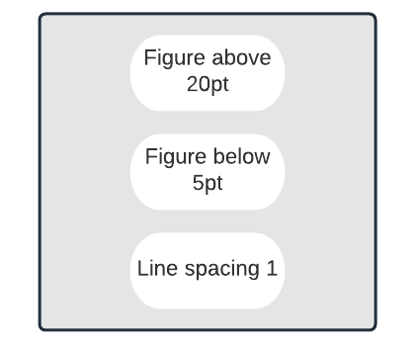

**Figure 1.** Above 5pt, below 20pt

Call the figures by its sequence number in the content and give enough explanations.

1. Results and Discussion

[Start typing here] - Times New Roman, font size: 12, Main document text size: 12, Times New Roman. Line spacing- 1.5.

Explain about the simulation models and simulation software. Additionally, include the comparison results with good quality pictures.

1. Conclusion

[Start typing here] - Times New Roman, font size: 12, Main document text size: 12, Times New Roman. Line spacing- 1.5.

Summarize the work carried out in the proposed work.

**References**

1. Author name1, Author name2. “Title of the paper”. Journal Name, Volume no, issue no, Page numbers. Use standard Chicago format.
2. Example, Duraipandian, M. "Performance evaluation of routing algorithm for Manet based on the machine learning techniques." Journal of trends in Computer Science and Smart technology (TCSST) 1, no. 01 (2019): 25-38.